**Course: 405-02: Mobile Application Development – 2**

**Unit-1: Project structure of Mobile Application:**

1.1 Internal details of Android Application:

1.1.1 Dalvik VM, Screen Orientation

**Dalvik Virtual Machine | DVM**

As we know the modern JVM is high performance and provides excellent memory management. But it needs to be optimized for low-powered handheld devices as well.

The **Dalvik Virtual Machine (DVM)** is an android virtual machine optimized for mobile devices. It optimizes the virtual machine for *memory*, *battery life* and *performance*.

Dalvik is a name of a town in Iceland. The Dalvik VM was written by Dan Bornstein.

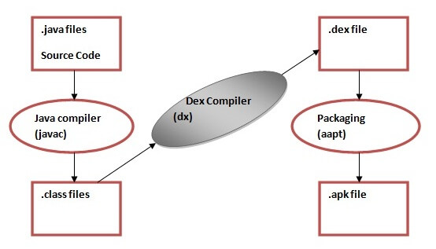The **Dex compiler** converts the class files into the .dex file that run on the Dalvik VM. Multiple class files are converted into one dex file.

Let's see the compiling and packaging process from the source file:

The **javac tool** compiles the java source file into the class file.

The **dx tool** takes all the class files of your application and generates a single .dex file. It is a platform-specific tool.

The **Android Assets Packaging Tool (aapt)** handles the packaging process.

**Screen Orientation**

The **screenOrientation** is the attribute of activity element. The orientation of android activity can be portrait, landscape, sensor, unspecified etc. You need to define it in the AndroidManifest.xml file.

**Syntax:**

1. **<activity** android:name="package_name.Your_ActivityName"
2. android:screenOrientation="orirntation_type"**>**
3. **</activity>**

**Example:**

1. **<activity** android:name=" example.javatpoint.com.screenorientation.MainActivity"
2. android:screenOrientation="portrait"**>**
3. **</activity>**
4. **<activity** android:name=".SecondActivity"
5. android:screenOrientation="landscape"**>**
6. **</activity>**

The common values for screenOrientation attribute are as follows:

|  |  |
| --- | --- |
| **Value** | **Description** |
| unspecified | It is the default value. In such case, system chooses the orientation. |
| portrait | taller not wider |
| landscape | wider not taller |
| sensor | orientation is determined by the device orientation sensor. |

Android Portrait and Landscape mode screen orientation example

In this example, we will create two activities of different screen orientation. The first activity (MainActivity) will be as "portrait" orientation and second activity (SecondActivity) as "landscape" orientation type.

activity_main.xml

*File: activity_main.xml*

<?xml version="1.0" encoding="utf-8"?>

<android.support.constraint.ConstraintLayout xmlns:android="http://schemas.android.com/apk/res/android"

xmlns:app="http://schemas.android.com/apk/res-auto"

xmlns:tools="http://schemas.android.com/tools"

android:layout_width="match_parent"

android:layout_height="match_parent"

tools:context="example.com.screenorientation.MainActivity">

<Button

android:id="@+id/button1"

android:layout_width="wrap_content"

android:layout_height="wrap_content"

android:layout_marginBottom="8dp"

android:layout_marginTop="112dp"

android:onClick="onClick"

android:text="Launch next activity"

app:layout_constraintBottom_toBottomOf="parent"

app:layout_constraintEnd_toEndOf="parent"

app:layout_constraintHorizontal_bias="0.612"

app:layout_constraintStart_toStartOf="parent"

app:layout_constraintTop_toBottomOf="@+id/editText1"

app:layout_constraintVertical_bias="0.613" />

<TextView

android:id="@+id/editText1"

android:layout_width="wrap_content"

android:layout_height="wrap_content"

android:layout_centerHorizontal="true"

android:layout_marginEnd="8dp"

android:layout_marginStart="8dp"

android:layout_marginTop="124dp"

android:ems="10"

android:textSize="22dp"

android:text="This activity is portrait orientation"

app:layout_constraintEnd_toEndOf="parent"

app:layout_constraintHorizontal_bias="0.502"

app:layout_constraintStart_toStartOf="parent"

app:layout_constraintTop_toTopOf="parent" />

</android.support.constraint.ConstraintLayout>

**Activity class**

*File: MainActivity.java*

package example.com.screenorientation;

import android.content.Intent;

import android.support.v7.app.AppCompatActivity;

import android.os.Bundle;

import android.view.View;

import android.widget.Button;

public class MainActivity extends AppCompatActivity {

Button button1;

@Override

protected void onCreate(Bundle savedInstanceState) {

super.onCreate(savedInstanceState);

setContentView(R.layout.activity_main);

button1=(Button)findViewById(R.id.button1);

}

public void onClick(View v) {

Intent intent = new Intent(MainActivity.this,SecondActivity.class);

startActivity(intent);

}

}

**activity_second.xml**

*File: activity_second.xml*

<?xml version="1.0" encoding="utf-8"?>

<android.support.constraint.ConstraintLayout xmlns:android="http://schemas.android.com/apk/res/android"

xmlns:app="http://schemas.android.com/apk/res-auto"

xmlns:tools="http://schemas.android.com/tools"

android:layout_width="match_parent"

android:layout_height="match_parent"

tools:context="example.com.screenorientation.SecondActivity">

<TextView

android:id="@+id/textView"

android:layout_width="wrap_content"

android:layout_height="wrap_content"

android:layout_marginEnd="8dp"

android:layout_marginStart="8dp"

android:layout_marginTop="180dp"

android:text="this is landscape orientation"

android:textSize="22dp"

app:layout_constraintEnd_toEndOf="parent"

app:layout_constraintHorizontal_bias="0.502"

app:layout_constraintStart_toStartOf="parent"

app:layout_constraintTop_toTopOf="parent" />

</android.support.constraint.ConstraintLayout>

SecondActivity class

*File: SecondActivity.java*

package example.com.screenorientation;

import android.support.v7.app.AppCompatActivity;

import android.os.Bundle;

public class SecondActivity extends AppCompatActivity {

@Override

protected void onCreate(Bundle savedInstanceState) {

super.onCreate(savedInstanceState);

setContentView(R.layout.activity_second);

}

}

**AndroidManifest.xml**

*File: AndroidManifest.xml*

In AndroidManifest.xml file add the screenOrientation attribute in activity and provides its orientation. In this example, we provide "portrait" orientation for MainActivity and "landscape" for SecondActivity.

<?xml version="1.0" encoding="utf-8"?>

<manifest xmlns:android="http://schemas.android.com/apk/res/android"

package="example.com.screenorientation">

<application

android:allowBackup="true"

android:icon="@mipmap/ic_launcher"

android:label="@string/app_name"

android:roundIcon="@mipmap/ic_launcher_round"

android:supportsRtl="true"

android:theme="@style/AppTheme">

<activity

android:name="example.com.screenorientation.MainActivity"

android:screenOrientation="portrait">

<intent-filter>

<action android:name="android.intent.action.MAIN" />

<category android:name="android.intent.category.LAUNCHER" />

</intent-filter>

</activity>

<activity android:name=".SecondActivity"

android:screenOrientation="landscape">

</activity>

</application>

</manifest>

Output:

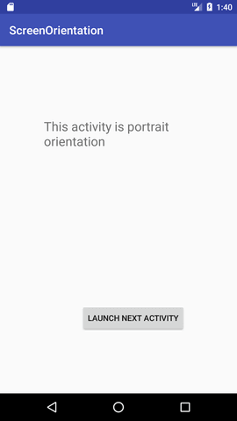 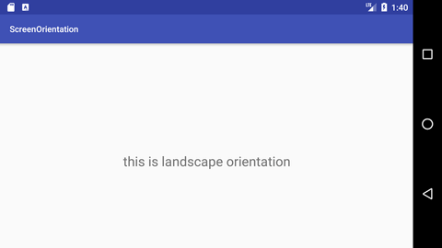

1.1.2 AndroidManifest, R.java

**AndroidManifest File**

The **AndroidManifest.xml file** *contains information of your package*, including components of the application such as activities, services, broadcast receivers, content providers etc.

It performs some other tasks also:

* It is **responsible to protect the application** to access any protected parts by providing the permissions.
* It also **declares the android api** that the application is going to use.
* It **lists the instrumentation classes**. The instrumentation classes provides profiling and other information. These information are removed just before the application is published etc.

This is the required xml file for all the android application and located inside the root directory.

A simple AndroidManifest.xml file looks like this:

<manifest xmlns:android="http://schemas.android.com/apk/res/android"

package="com.example.hello"

android:versionCode="1"

android:versionName="1.0" >

<uses-sdk

android:minSdkVersion="8"

android:targetSdkVersion="15" />

<application

android:icon="@drawable/ic_launcher"

android:label="@string/app_name"

android:theme="@style/AppTheme" >

<activity

android:name=".MainActivity"

android:label="@string/title_activity_main" >

<intent-filter>

<action android:name="android.intent.action.MAIN" />

<category android:name="android.intent.category.LAUNCHER" />

</intent-filter>

</activity>

</application>

</manifest>

Elements of the AndroidManifest.xml file

The elements used in the above xml file are described below.

<manifest>

**manifest** is the root element of the AndroidManifest.xml file. It has **package** attribute that describes the package name of the activity class.

<application>

**application** is the subelement of the manifest. It includes the namespace declaration. This element contains several subelements that declares the application component such as activity etc.

The commonly used attributes are of this element are **icon**, **label**, **theme** etc.

**android:icon** represents the icon for all the android application components.

**android:label** works as the default label for all the application components.

**android:theme** represents a common theme for all the android activities.

<activity>

**activity** is the subelement of application and represents an activity that must be defined in the AndroidManifest.xml file. It has many attributes such as label, name, theme, launchMode etc.

**android:label** represents a label i.e. displayed on the screen.

**android:name** represents a name for the activity class. It is required attribute.

<intent-filter>

**intent-filter** is the sub-element of activity that describes the type of intent to which activity, service or broadcast receiver can respond to.

<action>

It adds an action for the intent-filter. The intent-filter must have at least one action element.

<category>

It adds a category name to an intent-filter.

**Android R.java file**

**Android R.java** is *an auto-generated file by aapt* (Android Asset Packaging Tool) that contains resource IDs for all the resources of res/ directory.

If you create any component in the activity_main.xml file, id for the corresponding component is automatically created in this file. This id can be used in the activity source file to perform any action on the component.

Note: If you delete R.jar file, android creates it automatically.

Let's see the android R.java file. It includes a lot of static nested classes such as menu, id, layout, attr, drawable, string etc.

/* AUTO-GENERATED FILE.  DO NOT MODIFY.

 *

 * This class was automatically generated by the

 * aapt tool from the resource data it found.  It

 * should not be modified by hand.

 */

**package** com.example.helloandroid;

**public** **final** **class** R {

**public** **static** **final** **class** attr {

    }

**public** **static** **final** **class** drawable {

**public** **static** **final** **int** ic_launcher=0x7f020000;

    }

**public** **static** **final** **class** id {

**public** **static** **final** **int** menu_settings=0x7f070000;

    }

**public** **static** **final** **class** layout {

**public** **static** **final** **int** activity_main=0x7f030000;

    }

**public** **static** **final** **class** menu {

**public** **static** **final** **int** activity_main=0x7f060000;

    }

**public** **static** **final** **class** string {

**public** **static** **final** **int** app_name=0x7f040000;

**public** **static** **final** **int** hello_world=0x7f040001;

**public** **static** **final** **int** menu_settings=0x7f040002;

    }

**public** **static** **final** **class** style {

        /**

        Base application theme, dependent on API level. This theme is replaced

        by AppBaseTheme from res/values-vXX/styles.xml on newer devices.

            Theme customizations available in newer API levels can go in

            res/values-vXX/styles.xml, while customizations related to

            backward-compatibility can go here.

        Base application theme for API 11+. This theme completely replaces

        AppBaseTheme from res/values/styles.xml on API 11+ devices.

 API 11 theme customizations can go here.

        Base application theme for API 14+. This theme completely replaces

        AppBaseTheme from BOTH res/values/styles.xml and

        res/values-v11/styles.xml on API 14+ devices.

 API 14 theme customizations can go here.

         */

**public** **static** **final** **int** AppBaseTheme=0x7f050000;

        /**  Application theme.

 All customizations that are NOT specific to a particular API-level can go here.

         */

**public** **static** **final** **int** AppTheme=0x7f050001;

    }

}

1.2 Android Widgets (UI)

1.2.1 Default and Custom Checkbox

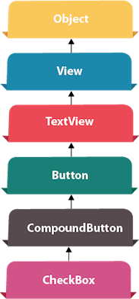**Android CheckBox** is a type of two state button either checked or unchecked.

There can be a lot of usage of checkboxes. For example, it can be used to know the hobby of the user, activate/deactivate the specific action etc.

Android CheckBox class is the subclass of CompoundButton class.

Android CheckBox class

The android.widget.CheckBox class provides the facility of creating the CheckBoxes.

**Methods of CheckBox class**

There are many inherited methods of View, TextView, and Button classes in the CheckBox class. Some of them are as follows:

|  |  |
| --- | --- |
| **Method** | **Description** |
| public boolean isChecked() | Returns true if it is checked otherwise false. |
| public void setChecked(boolean status) | Changes the state of the CheckBox. |

Android CheckBox Example

activity_main.xml

Drag the three checkboxes and one button for the layout. Now the activity_main.xml file will look like this:

*File: activity_main.xml*

**<?xml** version="1.0" encoding="utf-8"**?>**

**<android.support.constraint.ConstraintLayout** xmlns:android="http://schemas.android.com/apk/res/android"

    xmlns:app="http://schemas.android.com/apk/res-auto"

    xmlns:tools="http://schemas.android.com/tools"

    android:layout_width="match_parent"

    android:layout_height="match_parent"

    tools:context="example.javatpoint.com.checkbox.MainActivity"**>**

**<CheckBox**

        android:id="@+id/checkBox"

        android:layout_width="wrap_content"

        android:layout_height="wrap_content"

        android:layout_marginLeft="144dp"

        android:layout_marginTop="68dp"

        android:text="Pizza"

        app:layout_constraintStart_toStartOf="parent"

        app:layout_constraintTop_toTopOf="parent" **/>**

**<CheckBox**

        android:id="@+id/checkBox2"

        android:layout_width="wrap_content"

        android:layout_height="wrap_content"

        android:layout_marginLeft="144dp"

        android:layout_marginTop="28dp"

        android:text="Coffee"

        app:layout_constraintStart_toStartOf="parent"

        app:layout_constraintTop_toBottomOf="@+id/checkBox" **/>**

**<CheckBox**

        android:id="@+id/checkBox3"

        android:layout_width="wrap_content"

        android:layout_height="wrap_content"

        android:layout_marginLeft="144dp"

        android:layout_marginTop="28dp"

        android:text="Burger"

        app:layout_constraintStart_toStartOf="parent"

        app:layout_constraintTop_toBottomOf="@+id/checkBox2" **/>**

**<Button**

        android:id="@+id/button"

        android:layout_width="wrap_content"

        android:layout_height="wrap_content"

        android:layout_marginLeft="144dp"

        android:layout_marginTop="184dp"

        android:text="Order"

        app:layout_constraintStart_toStartOf="parent"

        app:layout_constraintTop_toBottomOf="@+id/checkBox3" **/>**

**</android.support.constraint.ConstraintLayout>**

Activity class

Let's write the code to check which toggle button is ON/OFF.

*File: MainActivity.java*

**package** example.com.checkbox;

**import** android.support.v7.app.AppCompatActivity;

**import** android.os.Bundle;

**import** android.view.View;

**import** android.widget.Button;

**import** android.widget.CheckBox;

**import** android.widget.Toast;

**public** **class** MainActivity **extends** AppCompatActivity {

    CheckBox pizza,coffe,burger;

    Button buttonOrder;

    @Override

**protected** **void** onCreate(Bundle savedInstanceState) {

**super**.onCreate(savedInstanceState);

        setContentView(R.layout.activity_main);

        addListenerOnButtonClick();

    }

**public** **void** addListenerOnButtonClick(){

        //Getting instance of CheckBoxes and Button from the activty_main.xml file

        pizza=(CheckBox)findViewById(R.id.checkBox);

        coffe=(CheckBox)findViewById(R.id.checkBox2);

        burger=(CheckBox)findViewById(R.id.checkBox3);

        buttonOrder=(Button)findViewById(R.id.button);

        //Applying the Listener on the Button click

        buttonOrder.setOnClickListener(**new** View.OnClickListener(){

            @Override

**public** **void** onClick(View view) {

**int** totalamount=0;

                StringBuilder result=**new** StringBuilder();

                result.append("Selected Items:");

**if**(pizza.isChecked()){

                    result.append("\nPizza 100Rs");

                    totalamount+=100;

                }

**if**(coffe.isChecked()){

                    result.append("\nCoffe 50Rs");

                    totalamount+=50;

                }

**if**(burger.isChecked()){

                    result.append("\nBurger 120Rs");

                    totalamount+=120;

                }

                result.append("\nTotal: "+totalamount+"Rs");

                //Displaying the message on the toast

                Toast.makeText(getApplicationContext(), result.toString(), Toast.LENGTH_LONG).show();

            }

        });

    }

}

Output:

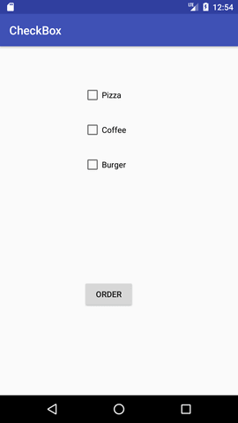 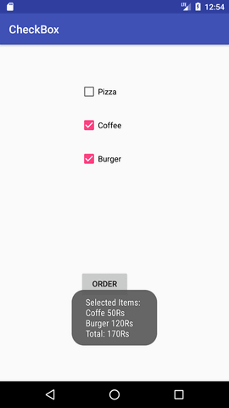

**Android Custom CheckBox**

Android provides facility to customize the UI of view elements rather than default.

You are able to create custom CheckBox in android. So, you can add some different images of checkbox on the layout.

Example of Custom CheckBox

In this example, we create both default as well as custom checkbox. Add the following code in activity_main.xml file.

activity_main.xml

**File: activity_main.xml**

**<?xml** version="1.0" encoding="utf-8"**?>**

**<RelativeLayout** xmlns:android="http://schemas.android.com/apk/res/android"

    xmlns:app="http://schemas.android.com/apk/res-auto"

    xmlns:tools="http://schemas.android.com/tools"

    android:layout_width="match_parent"

    android:layout_height="match_parent"

    tools:context="example.javatpoint.com.customcheckbox.MainActivity"**>**

**<TextView**

        android:id="@+id/textView1"

        android:layout_width="fill_parent"

        android:layout_height="wrap_content"

        android:gravity="center_horizontal"

        android:textSize="25dp"

        android:text="Default Check Box"

        android:layout_alignParentTop="true"

        android:layout_alignParentLeft="true"

        android:layout_alignParentStart="true" **/>**

**<CheckBox**

        android:layout_width="wrap_content"

        android:layout_height="wrap_content"

        android:text="New CheckBox"

        android:id="@+id/checkBox"

        android:layout_below="@+id/textView1"

        android:layout_centerHorizontal="true"

        android:layout_marginTop="46dp" **/>**

**<CheckBox**

        android:layout_width="wrap_content"

        android:layout_height="wrap_content"

        android:text="New CheckBox"

        android:id="@+id/checkBox2"

        android:layout_below="@+id/checkBox"

        android:layout_alignLeft="@+id/checkBox"

        android:layout_alignStart="@+id/checkBox" **/>**

**<View**

        android:layout_width="fill_parent"

        android:layout_height="1dp"

        android:layout_marginTop="200dp"

        android:background="#B8B894"

        android:id="@+id/viewStub" **/>**

**<CheckBox**

        android:layout_width="wrap_content"

        android:layout_height="wrap_content"

        android:text="CheckBox 1"

        android:id="@+id/checkBox3"

        android:button="@drawable/customcheckbox"

        android:layout_below="@+id/viewStub"

        android:layout_centerHorizontal="true"

        android:layout_marginTop="58dp" **/>**

**<CheckBox**

        android:layout_width="wrap_content"

        android:layout_height="wrap_content"

        android:text="CheckBox 2"

        android:id="@+id/checkBox4"

        android:button="@drawable/customcheckbox"

        android:layout_below="@+id/checkBox3"

        android:layout_alignLeft="@+id/checkBox3"

        android:layout_alignStart="@+id/checkBox3" **/>**

**<TextView**

        android:layout_width="wrap_content"

        android:layout_height="wrap_content"

        android:textAppearance="?android:attr/textAppearanceSmall"

        android:textSize="25dp"

        android:text="Custom Check Box"

        android:id="@+id/textView"

        android:layout_alignTop="@+id/viewStub"

        android:layout_centerHorizontal="true" **/>**

**<Button**

        android:layout_width="wrap_content"

        android:layout_height="wrap_content"

        android:text="Show Checked"

        android:id="@+id/button"

        android:layout_alignParentBottom="true"

        android:layout_centerHorizontal="true" **/>**

**</RelativeLayout>**

Now implement a selector in another file (checkbox.xml) under drawable folder which customizes the checkbox.

checkbox.xml

**File: checkbox.xml**

**<?xml** version="1.0" encoding="utf-8"**?>**

**<selector** xmlns:android="http://schemas.android.com/apk/res/android"**>**

**<item** android:state_checked="true" android:drawable="@drawable/checked" **/>**

**<item** android:state_checked="false" android:drawable="@drawable/unchecked"**/>**

**</selector>**

Activity class

**File: MainActivity.java**

**package** example.com.customcheckbox;

**import** android.support.v7.app.AppCompatActivity;

**import** android.os.Bundle;

**import** android.view.View;

**import** android.widget.Button;

**import** android.widget.CheckBox;

**import** android.widget.Toast;

**public** **class** MainActivity **extends** AppCompatActivity {

    CheckBox cb1,cb2;

    Button button;

    @Override

**protected** **void** onCreate(Bundle savedInstanceState) {

**super**.onCreate(savedInstanceState);

        setContentView(R.layout.activity_main);

        cb1=(CheckBox)findViewById(R.id.checkBox3);

        cb2=(CheckBox)findViewById(R.id.checkBox4);

        button=(Button)findViewById(R.id.button);

        button.setOnClickListener(**new** View.OnClickListener() {

            @Override

**public** **void** onClick(View v) {

                StringBuilder sb=**new** StringBuilder("");

**if**(cb1.isChecked()){

                    String s1=cb1.getText().toString();

                    sb.append(s1);

                }

**if**(cb2.isChecked()){

                    String s2=cb2.getText().toString();

                    sb.append("\n"+s2);

                }

**if**(sb!=**null** && !sb.toString().equals("")){

                    Toast.makeText(getApplicationContext(), sb, Toast.LENGTH_LONG).show();

                }

**else**{

                    Toast.makeText(getApplicationContext(),"Nothing Selected", Toast.LENGTH_LONG).show();

                }

            }

        });

    }

}

Output:

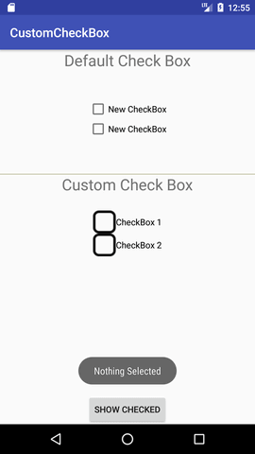 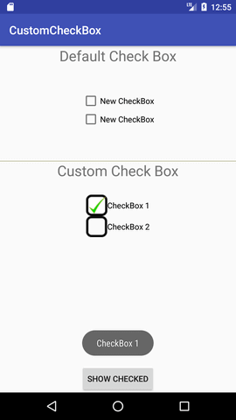

1.2.2 Dynamic and Custom RadioButton

**Android RadioButton**

**RadioButton** is a two states button which is either checked or unchecked. If a single radio button is unchecked, we can click it to make checked radio button. Once a radio button is checked, it cannot be marked as unchecked by user.

RadioButton is generally used with *RadioGroup*. RadioGroup contains several radio buttons, marking one radio button as checked makes all other radio buttons as unchecked.

Example of Radio Button

In this example, we are going to implement single radio button separately as well as radio button in **RadioGroup**.

activity_main.xml

**File: activity_main.xml**

**<?xml** version="1.0" encoding="utf-8"**?>**

**<LinearLayout**

    xmlns:android="http://schemas.android.com/apk/res/android"

    xmlns:tools="http://schemas.android.com/tools"

    android:layout_width="match_parent"

    android:layout_height="match_parent"

    android:orientation="vertical"

    tools:context="example.com.radiobutton.MainActivity"**>**

**<TextView**

        android:id="@+id/textView1"

        android:layout_width="fill_parent"

        android:layout_height="wrap_content"

        android:layout_marginTop="30dp"

        android:gravity="center_horizontal"

        android:textSize="22dp"

        android:text="Single Radio Buttons" **/>**

    <!--   Default RadioButtons  -->

**<RadioButton**

        android:id="@+id/radioButton1"

        android:layout_width="fill_parent"

        android:layout_height="wrap_content"

        android:layout_gravity="center_horizontal"

        android:text="Radio Button 1"

        android:layout_marginTop="20dp"

        android:textSize="20dp" **/>**

**<RadioButton**

        android:id="@+id/radioButton2"

        android:layout_width="fill_parent"

        android:layout_height="wrap_content"

        android:text="Radio Button 2"

        android:layout_marginTop="10dp"

        android:textSize="20dp" **/>**

**<View**

        android:layout_width="fill_parent"

        android:layout_height="1dp"

        android:layout_marginTop="20dp"

        android:background="#B8B894" **/>**

**<TextView**

        android:id="@+id/textView2"

        android:layout_width="fill_parent"

        android:layout_height="wrap_content"

        android:layout_marginTop="30dp"

        android:gravity="center_horizontal"

        android:textSize="22dp"

        android:text="Radio button inside RadioGroup" **/>**

    <!--   Customized RadioButtons  -->

**<RadioGroup**

        android:layout_width="wrap_content"

        android:layout_height="wrap_content"

        android:id="@+id/radioGroup"**>**

**<RadioButton**

            android:id="@+id/radioMale"

            android:layout_width="fill_parent"

            android:layout_height="wrap_content"

            android:text="  Male"

            android:layout_marginTop="10dp"

            android:checked="false"

            android:textSize="20dp" **/>**

**<RadioButton**

            android:id="@+id/radioFemale"

            android:layout_width="fill_parent"

            android:layout_height="wrap_content"

            android:text="   Female"

            android:layout_marginTop="20dp"

            android:checked="false"

            android:textSize="20dp" **/>**

**</RadioGroup>**

**<Button**

        android:layout_width="wrap_content"

        android:layout_height="wrap_content"

        android:text="Show Selected"

        android:id="@+id/button"

        android:onClick="onclickbuttonMethod"

        android:layout_gravity="center_horizontal" **/>**

**</LinearLayout>**

Activity class

**File: MainActivity.java**

**package** example.com.radiobutton;

**import** android.support.v7.app.AppCompatActivity;

**import** android.os.Bundle;

**import** android.view.View;

**import** android.widget.Button;

**import** android.widget.RadioButton;

**import** android.widget.RadioGroup;

**import** android.widget.Toast;

**public** **class** MainActivity **extends** AppCompatActivity {

    Button button;

    RadioButton genderradioButton;

    RadioGroup radioGroup;

    @Override

**protected** **void** onCreate(Bundle savedInstanceState) {

**super**.onCreate(savedInstanceState);

        setContentView(R.layout.activity_main);

        radioGroup=(RadioGroup)findViewById(R.id.radioGroup);

    }

**public** **void** onclickbuttonMethod(View v){

**int** selectedId = radioGroup.getCheckedRadioButtonId();

        genderradioButton = (RadioButton) findViewById(selectedId);

**if**(selectedId==-1){

            Toast.makeText(MainActivity.**this**,"Nothing selected", Toast.LENGTH_SHORT).show();

        }

**else**{

            Toast.makeText(MainActivity.**this**,genderradioButton.getText(), Toast.LENGTH_SHORT).show();

        }

    }

}

Output:

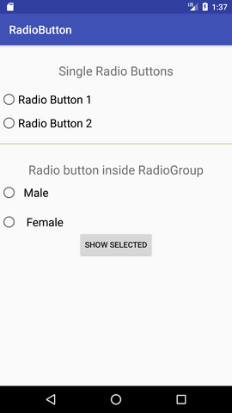 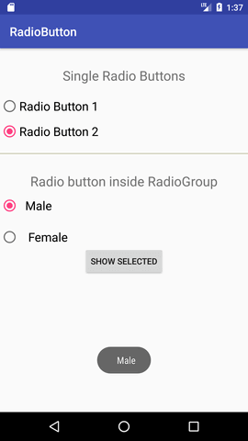

**Android Dynamic RadioButton**

Instead of creating RadioButton through drag and drop from palette, android also facilitates you to create it programmatically (dynamically). For creating dynamic RadioButton, we need to use **android.view.ViewGroup.LayoutParams** which configures the width and height of views and implements *setOnCheckedChangeListener()* method of *RadioGroup* class.

Example of Dynamic RadioButton

Let's see an example of Dynamic RadioButton.

activity_main.xml

***File: activity_main.xml***

**<?xml** version="1.0" encoding="utf-8"**?>**

**<RelativeLayout** xmlns:android="http://schemas.android.com/apk/res/android"

    xmlns:tools="http://schemas.android.com/tools"

    android:layout_width="match_parent"

    android:layout_height="match_parent"

    android:paddingBottom="@dimen/activity_vertical_margin"

    android:paddingLeft="@dimen/activity_horizontal_margin"

    android:paddingRight="@dimen/activity_horizontal_margin"

    android:paddingTop="@dimen/activity_vertical_margin"

    android:id="@+id/relativeLayout"

    tools:context="com.example.test.dynamicradiobutton.MainActivity"**>**

**</RelativeLayout>**

Activity class

***File: MainActivity.java***

**package** com.example.test.dynamicradiobutton;

**import** android.support.v7.app.AppCompatActivity;

**import** android.os.Bundle;

**import** android.widget.RadioButton;

**import** android.widget.RadioGroup;

**import** android.widget.RelativeLayout;

**import** android.widget.RelativeLayout.LayoutParams;

**import** android.widget.Toast;

**public** **class** MainActivity **extends** AppCompatActivity {

    RadioGroup rg;

    RelativeLayout rl;

    RadioButton rb1,rb2;

    @Override

**protected** **void** onCreate(Bundle savedInstanceState) {

**super**.onCreate(savedInstanceState);

        setContentView(R.layout.activity_main);

        rg = **new** RadioGroup(**this**);

        rl = (RelativeLayout) findViewById(R.id.relativeLayout);

        rb1 = **new** RadioButton(**this**);

        rb2 = **new** RadioButton(**this**);

        rb1.setText("Male");

        rb2.setText("Female");

        rg.addView(rb1);

        rg.addView(rb2);

        rg.setOrientation(RadioGroup.HORIZONTAL);

        RelativeLayout.LayoutParams params = **new** RelativeLayout.LayoutParams((**int**) LayoutParams.WRAP_CONTENT,(**int**)LayoutParams.WRAP_CONTENT);

        params.leftMargin =150;

        params.topMargin = 100;

        rg.setLayoutParams(params);

        rl.addView(rg);

        rg.setOnCheckedChangeListener(**new** RadioGroup.OnCheckedChangeListener() {

            @Override

**public** **void** onCheckedChanged(RadioGroup group, **int** checkedId) {

                RadioButton radioButton = (RadioButton) findViewById(checkedId);

                Toast.makeText(getApplicationContext(),radioButton.getText(),Toast.LENGTH_LONG).show();

            }

        });

    }

}

Output:

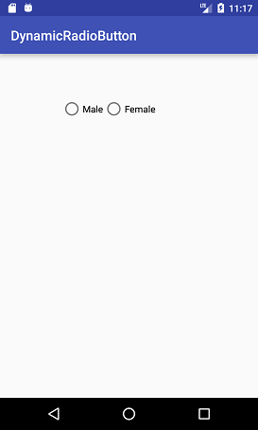 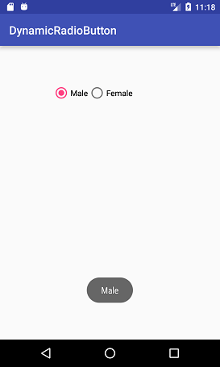

**Android Custom RadioButton**

Rather than default user interface of android RadioButton, we can also implement a custom radio button. Custom RadioButton makes user interface more attractive.

Example of Custom RadioButton

Let's see an example of custom RadioButton.

activity_main.xml

**File: activity_main.xml**

**<?xml** version="1.0" encoding="utf-8"**?>**

**<LinearLayout**

    xmlns:android="http://schemas.android.com/apk/res/android"

    xmlns:tools="http://schemas.android.com/tools"

    android:layout_width="match_parent"

    android:layout_height="match_parent"

    android:paddingBottom="@dimen/activity_vertical_margin"

    android:paddingLeft="@dimen/activity_horizontal_margin"

    android:paddingRight="@dimen/activity_horizontal_margin"

    android:paddingTop="@dimen/activity_vertical_margin"

    android:orientation="vertical"

    tools:context="com.example.test.customradiobutton.MainActivity"**>**

**<TextView**

        android:id="@+id/tv"

        android:layout_width="fill_parent"

        android:layout_height="wrap_content"

        android:layout_marginTop="30dp"

        android:gravity="center_horizontal"

        android:textSize="25dp"

        android:text="Customized Radio Buttons" **/>**

    <!--   Customized RadioButtons  -->

**<RadioGroup**

        android:layout_width="wrap_content"

        android:layout_height="wrap_content"

        android:id="@+id/radioGroup"**>**

**<RadioButton**

            android:id="@+id/radioMale"

            android:layout_width="fill_parent"

            android:layout_height="wrap_content"

            android:text="  Male"

            android:layout_marginTop="10dp"

            android:checked="false"

            android:button="@drawable/custom_radio_button"

            android:textSize="20dp" **/>**

**<RadioButton**

            android:id="@+id/radioFemale"

            android:layout_width="fill_parent"

            android:layout_height="wrap_content"

            android:text="   Female"

            android:layout_marginTop="20dp"

            android:checked="false"

            android:button="@drawable/custom_radio_button"

            android:textSize="20dp" **/>**

**</RadioGroup>**

**<Button**

        android:layout_width="wrap_content"

        android:layout_height="wrap_content"

        android:text="Show Selected"

        android:id="@+id/button"

        android:onClick="onclickbuttonMethod"

        android:layout_gravity="center_horizontal" **/>**

**</LinearLayout>**

custom_radio_button.xml

Now implement a selector in another file (custom_radio_button.xml) in drawable and place two different checked and unchecked button images.

**File: checkbox.xml**

**<?xml** version="1.0" encoding="utf-8"**?>**

**<selector** xmlns:android="http://schemas.android.com/apk/res/android"**>**

**<item** android:state_checked="true" android:drawable="@drawable/checkedradiobutton" **/>**

**<item** android:state_checked="false" android:drawable="@drawable/unchekedradiobutton" **/>**

**</selector>**

Activity class

**File: MainActivity.java**

**package** com.example.test.customradiobutton;

**import** android.support.v7.app.AppCompatActivity;

**import** android.os.Bundle;

**import** android.view.View;

**import** android.widget.Button;

**import** android.widget.RadioButton;

**import** android.widget.RadioGroup;

**import** android.widget.Toast;

**public** **class** MainActivity **extends** AppCompatActivity {

    Button button;

    RadioButton genderradioButton;

    RadioGroup radioGroup;

    @Override

**protected** **void** onCreate(Bundle savedInstanceState) {

**super**.onCreate(savedInstanceState);

        setContentView(R.layout.activity_main);

        radioGroup=(RadioGroup)findViewById(R.id.radioGroup);

    }

**public** **void** onclickbuttonMethod(View v){

**int** selectedId = radioGroup.getCheckedRadioButtonId();

        genderradioButton = (RadioButton) findViewById(selectedId);

**if**(selectedId==-1){

            Toast.makeText(MainActivity.**this**,"Nothing selected", Toast.LENGTH_SHORT).show();

        }

**else**{

            Toast.makeText(MainActivity.**this**,genderradioButton.getText(), Toast.LENGTH_SHORT).show();

        }

    }

}

Output:

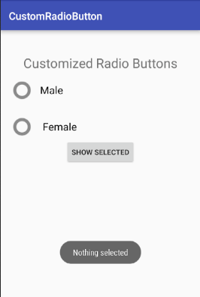 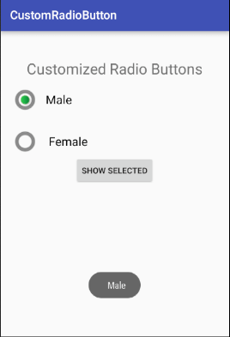

1.2.3 Spinner, AlterDialog

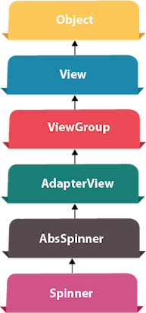

**Android Spinner**

**Android Spinner** is like the combox box of AWT or Swing. It can be used to display the multiple options to the user in which only one item can be selected by the user.

Android spinner is like the drop down menu with multiple values from which the end user can select only one value.

Android spinner is associated with AdapterView. So you need to use one of the adapter classes with spinner.

Android Spinner class is the subclass of AsbSpinner class.

**Android Spinner Example**

In this example, we are going to display the country list. You need to use **ArrayAdapter** class to store the country list.

Let's see the simple example of spinner in android.

activity_main.xml

Drag the Spinner from the pallete, now the activity_main.xml file will like this:

*File: activity_main.xml*

**<?xml** version="1.0" encoding="utf-8"**?>**

**<android.support.constraint.ConstraintLayout** xmlns:android="http://schemas.android.com/apk/res/android"

    xmlns:app="http://schemas.android.com/apk/res-auto"

    xmlns:tools="http://schemas.android.com/tools"

    android:layout_width="match_parent"

    android:layout_height="match_parent"

    tools:context="example.javatpoint.com.spinner.MainActivity"**>**

**<Spinner**

        android:id="@+id/spinner"

        android:layout_width="149dp"

        android:layout_height="40dp"

        android:layout_marginBottom="8dp"

        android:layout_marginEnd="8dp"

        android:layout_marginStart="8dp"

        android:layout_marginTop="8dp"

        app:layout_constraintBottom_toBottomOf="parent"

        app:layout_constraintEnd_toEndOf="parent"

        app:layout_constraintHorizontal_bias="0.502"

        app:layout_constraintStart_toStartOf="parent"

        app:layout_constraintTop_toTopOf="parent"

        app:layout_constraintVertical_bias="0.498" **/>**

**</android.support.constraint.ConstraintLayout>**

Activity class

Let's write the code to display item on the spinner and perform event handling.

*File: MainActivity.java*

**package** example.javatpoint.com.spinner;

**import** android.support.v7.app.AppCompatActivity;

**import** android.os.Bundle;

**import** android.view.View;

**import** android.widget.AdapterView;

**import** android.widget.ArrayAdapter;

**import** android.widget.Spinner;

**import** android.widget.Toast;

**public** **class** MainActivity **extends** AppCompatActivity **implements**

        AdapterView.OnItemSelectedListener {

    String[] country = { "India", "USA", "China", "Japan", "Other"};

    @Override

**protected** **void** onCreate(Bundle savedInstanceState) {

**super**.onCreate(savedInstanceState);

        setContentView(R.layout.activity_main);

       //Getting the instance of Spinner and applying OnItemSelectedListener on it

        Spinner spin = (Spinner) findViewById(R.id.spinner);

        spin.setOnItemSelectedListener(**this**);

        //Creating the ArrayAdapter instance having the country list

        ArrayAdapter aa = **new** ArrayAdapter(**this**,android.R.layout.simple_spinner_item,country);

        aa.setDropDownViewResource(android.R.layout.simple_spinner_dropdown_item);

        //Setting the ArrayAdapter data on the Spinner

        spin.setAdapter(aa);

    }

    //Performing action onItemSelected and onNothing selected

    @Override

**public** **void** onItemSelected(AdapterView<?> arg0, View arg1, **int** position, **long** id) {

        Toast.makeText(getApplicationContext(),country[position] , Toast.LENGTH_LONG).show();

    }

    @Override

**public** **void** onNothingSelected(AdapterView<?> arg0) {

        // TODO Auto-generated method stub

    }

}

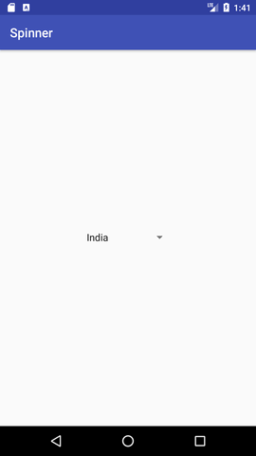 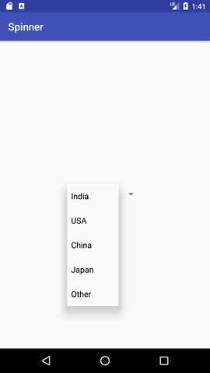 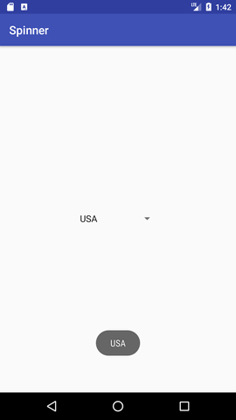

**Android AlertDialog**

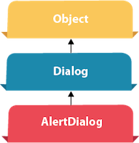**Android AlertDialog** can be used to display the dialog message with OK and Cancel buttons. It can be used to interrupt and ask the user about his/her choice to continue or discontinue.

Android AlertDialog is composed of three regions: title, content area and action buttons.

Android AlertDialog is the subclass of Dialog class.

Methods of AlertDialog class

|  |  |
| --- | --- |
| **Method** | **Description** |
| public AlertDialog.Builder setTitle(CharSequence) | This method is used to set the title of AlertDialog. |
| public AlertDialog.Builder setMessage(CharSequence) | This method is used to set the message for AlertDialog. |
| public AlertDialog.Builder setIcon(int) | This method is used to set the icon over AlertDialog. |

Android AlertDialog Example

Let's see a simple example of android alert dialog.

activity_main.xml

You can have multiple components, here we are having only a textview.

*File: activity_main.xml*

**<?xml** version="1.0" encoding="utf-8"**?>**

**<android.support.constraint.ConstraintLayout** xmlns:android="http://schemas.android.com/apk/res/android"

    xmlns:app="http://schemas.android.com/apk/res-auto"

    xmlns:tools="http://schemas.android.com/tools"

    android:layout_width="match_parent"

    android:layout_height="match_parent"

    tools:context="example.javatpoint.com.alertdialog.MainActivity"**>**

**<Button**

        android:layout_width="wrap_content"

        android:layout_height="wrap_content"

        android:id="@+id/button"

        android:text="Close app"

        app:layout_constraintBottom_toBottomOf="parent"

        app:layout_constraintLeft_toLeftOf="parent"

        app:layout_constraintRight_toRightOf="parent"

        app:layout_constraintTop_toTopOf="parent" **/>**

**</android.support.constraint.ConstraintLayout>**

strings.xml

Optionally, you can store the dialog message and title in the strings.xml file.

*File: strings.xml*

**<resources>**

**<string** name="app_name"**>**AlertDialog**</string>**

**<string** name="dialog_message"**>**Welcome to Alert Dialog**</string>**

**<string** name="dialog_title"**>**Javatpoint Alert Dialog**</string>**

**</resources>**

Activity class

Let's write the code to create and show the AlertDialog.

*File: MainActivity.java*

**package** example.com.alertdialog;

**import** android.content.DialogInterface;

**import** android.support.v7.app.AppCompatActivity;

**import** android.os.Bundle;

**import** android.view.View;

**import** android.widget.Button;

**import** android.app.AlertDialog;

**import** android.widget.Toast;

**public** **class** MainActivity **extends** AppCompatActivity {

    Button closeButton;

    AlertDialog.Builder builder;

    @Override

**protected** **void** onCreate(Bundle savedInstanceState) {

**super**.onCreate(savedInstanceState);

        setContentView(R.layout.activity_main);

        closeButton = (Button) findViewById(R.id.button);

        builder = **new** AlertDialog.Builder(**this**);

        closeButton.setOnClickListener(**new** View.OnClickListener() {

            @Override

**public** **void** onClick(View v) {

                //Uncomment the below code to Set the message and title from the strings.xml file

                builder.setMessage(R.string.dialog_message) .setTitle(R.string.dialog_title);

                //Setting message manually and performing action on button click

                builder.setMessage("Do you want to close this application ?")

                        .setCancelable(**false**)

                        .setPositiveButton("Yes", **new** DialogInterface.OnClickListener() {

**public** **void** onClick(DialogInterface dialog, **int** id) {

                                finish();

                                Toast.makeText(getApplicationContext(),"you choose yes action for alertbox",

                                Toast.LENGTH_SHORT).show();

                            }

                        })

                        .setNegativeButton("No", **new** DialogInterface.OnClickListener() {

**public** **void** onClick(DialogInterface dialog, **int** id) {

                                //  Action for 'NO' Button

                                dialog.cancel();

                                Toast.makeText(getApplicationContext(),"you choose no action for alertbox",

                                Toast.LENGTH_SHORT).show();

                            }

                        });

                //Creating dialog box

                AlertDialog alert = builder.create();

                //Setting the title manually

                alert.setTitle("AlertDialogExample");

                alert.show();

            }

        });

    }

}

Output:

